MIE1624 | Canada AI Competitiveness Project
Expected Results, Strategic Impact & Conclusion
Final Report — Section 4 of 4 | University of Toronto, Winter 2026

5. Expected Results and Strategic Impact

5.1 Canada’s Baseline Position and the Cost of Inaction

Canada enters the projection horizon ranked 5th globally, with a composite AI competitiveness score of 32.86 out of 100. This position sits within less than one composite point of 4th-ranked Singapore (33.04) — a gap that appears narrow but is fragile. The modelled baseline trajectory reflects competitive drift from peer nations improving their own positions absent any new Canadian policy action. Without intervention, Canada falls to 6th place by mid-2027 and remains there through the end of the projection horizon in 2029 Q4.
The underlying driver of that drift is structural. Canada’s Government Strategy score is already at its maximum (100.0), and its Operating Environment score (93.94) is among the strongest in the ranking. These are genuine strengths. However, they represent the policy architecture, not the outcomes that architecture should produce. Canada’s Commercial Ecosystem score stands at just 14.88, its AI Investment Activity at 3.16, and its domestic AI Adoption rate at 8.0 — all materially below peer-cluster comparators. The gap is not strategic intent: it is the conversion from strengths into retained talent, scaled firms, and domestic market traction.

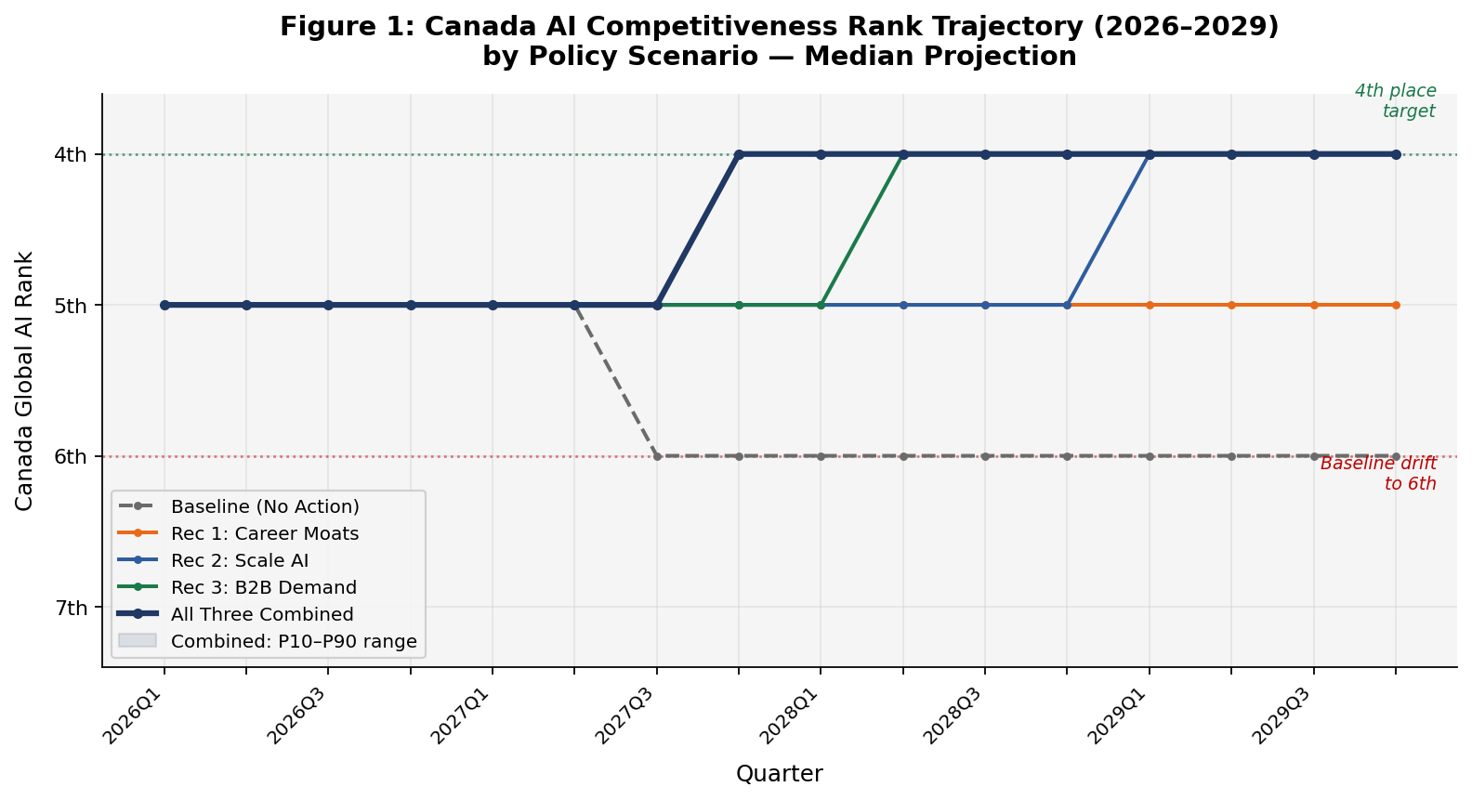
Figure 1: Canada AI Competitiveness Rank Trajectory by Policy Scenario (2026–2029). Median projection shown; dashed line = baseline with no policy action.

5.2 What the Recommendations Are Expected to Achieve

The three recommendations are modelled both as stand-alone counterfactuals and as a combined package, over a quarterly simulation covering 16 quarters (2026 Q1 – 2029 Q4). All results reflect the median Monte Carlo outcome. The table below presents end-of-horizon results across all scenarios.

Scenario | End Score | End Rank | Gain vs. Baseline
Baseline — No new policy | 32.86 | 6th | —
Recommendation 1 only – Career Moats | 33.87 | 5th | +1.01
Recommendation 2 only – Scale AI | 34.42 | 4th | +1.55
Recommendation 3 only – B2B Demand Credits | 34.36 | 4th | +1.49
All Three Recommendations Combined | 36.93 | 4th | +4.07

Table 1: Scenario Comparison — Canada Composite Score and Rank at End of Horizon (2029 Q4)

Each recommendation moves Canada’s position, but at different speeds and through different channels. The most significant finding lies in the combined scenario: a composite gain of approximately 4.07 points — materially larger than any individual recommendation, reflecting meaningful complementarity across the three levers.
The combined scenario locks in a 4th-place ranking by the end of 2027 Q4, approximately 18 months into the implementation horizon. Stand-alone Recommendations 2 and 3 each reach 4th place, but not until mid-to-late 2028. Recommendation 1 alone prevents the baseline deterioration to 6th, but does not reach 4th within the modelled period. The sequencing matters: Recommendation 1 builds the talent foundation; Recommendations 2 and 3 activate the commercial and demand channels that convert that talent into outcomes. Together, the package accelerates Canada’s competitiveness trajectory by approximately two to three quarters compared to the best single-recommendation path.

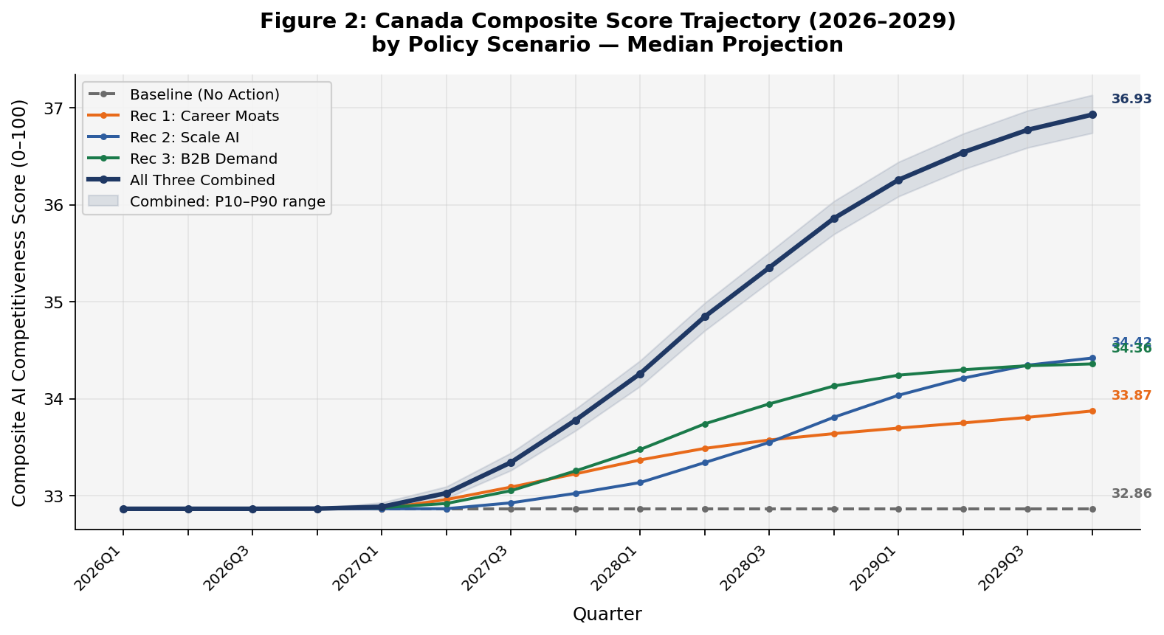
Figure 2: Canada Composite Score Trajectory by Scenario (2026–2029). Median projection; shaded band = P10–P90 uncertainty range for the combined scenario.

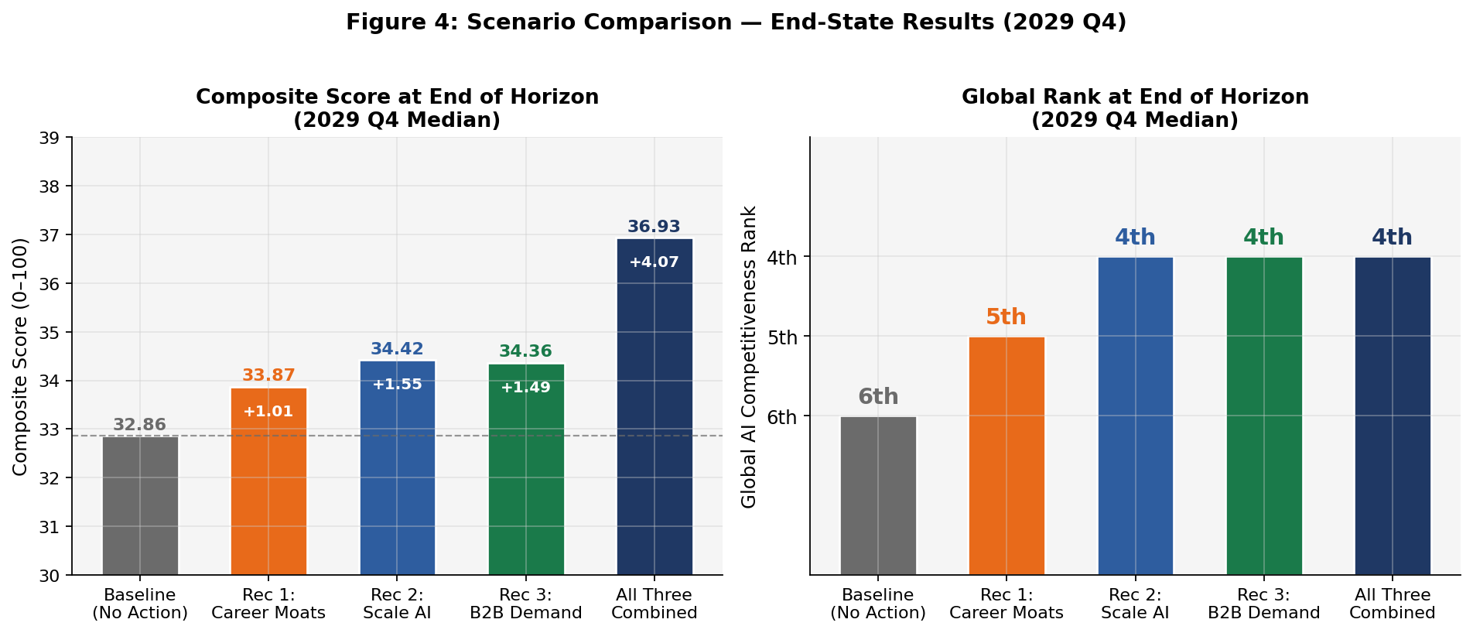
Figure 4: End-State Scenario Comparison — Composite Score (left) and Global Rank (right) at 2029 Q4.

5.3 KPI-Level Impact: What Changes, and Where

The recommendations address different, though overlapping, KPI groups. Understanding which levers move which indicators is important both for tracking implementation success and interpreting the limits of any individual policy path.

Recommendation 1 — Build Career Moats for Talent targets Canada’s talent retention and attraction KPIs most directly. In the stand-alone scenario at end of horizon, the Tortoise Talent Score improves by approximately 4.66 points — closing more than 55% of the gap between Canada’s baseline and the peer-best (UK). The AI Hiring Rate improves by approximately 3.73 points (a ~14% gap closure vs. global best), and Net Migration Flow of AI Skills gains roughly 3.57 points. Job Postings as a share of employment improves by approximately 2.76 points. The recommendation also produces modest downstream gains in the Commercial Ecosystem score (+0.83 points) as retained talent supports early-stage commercialization. What it primarily achieves is preventing the talent-drain dynamic from compounding: without it, Canada’s talent profile erodes as peer nations accelerate their own retention programmes.
Recommendation 2 — Build the Conditions to Scale AI in Canada produces the strongest impact on commercial ecosystem and investment KPIs. In the stand-alone scenario, the Tortoise Commercial Score improves by approximately 8.50 points, fully closing the peer-cluster gap versus the UK benchmark (100% closure). AI Investment Activity improves by approximately 6.17 points (also 100% peer-gap closure), and AI Adoption rises by approximately 2.12 points. The Development Score also improves modestly (+0.63 points) as scale-up vehicles begin generating commercial applications and early IP. Net Migration Flow gains approximately 1.35 points, as a healthier commercial environment makes Canada a more attractive destination for international AI talent.
Recommendation 3 — Stimulate B2B Demand via Adoption Credits has the strongest impact on AI Adoption, improving by approximately 5.72 points (closing nearly 48% of the peer-cluster gap). The Tortoise Commercial Score improves by approximately 7.63 points (full peer-gap closure), and AI Investment Activity gains approximately 4.88 points. The recommendation also produces the largest modelled improvement in AI Patent Grants (+0.63 points vs. global best), as first-customer adoption mandates with IP eligibility rules incentivize domestic productization. Job Postings improve by approximately 2.75 points, and net migration flows gain modestly as commercial traction signals draw skilled workers toward a credibly growing market.
In the combined scenario, these effects compound. The most significant combined movements by end of horizon are: Tortoise Commercial Score +17.0 points; AI Investment Activity +11.1 points; AI Job Postings +9.6 points; AI Adoption +7.8 points; and Net Migration Flow +6.2 points. Research and development scores improve modestly (+0.80 and +1.26 points respectively), reflecting the longer time horizons typically required for research pipeline changes to register in observable output metrics. Infrastructure scores remain unchanged, consistent with the scope of the three recommendations.

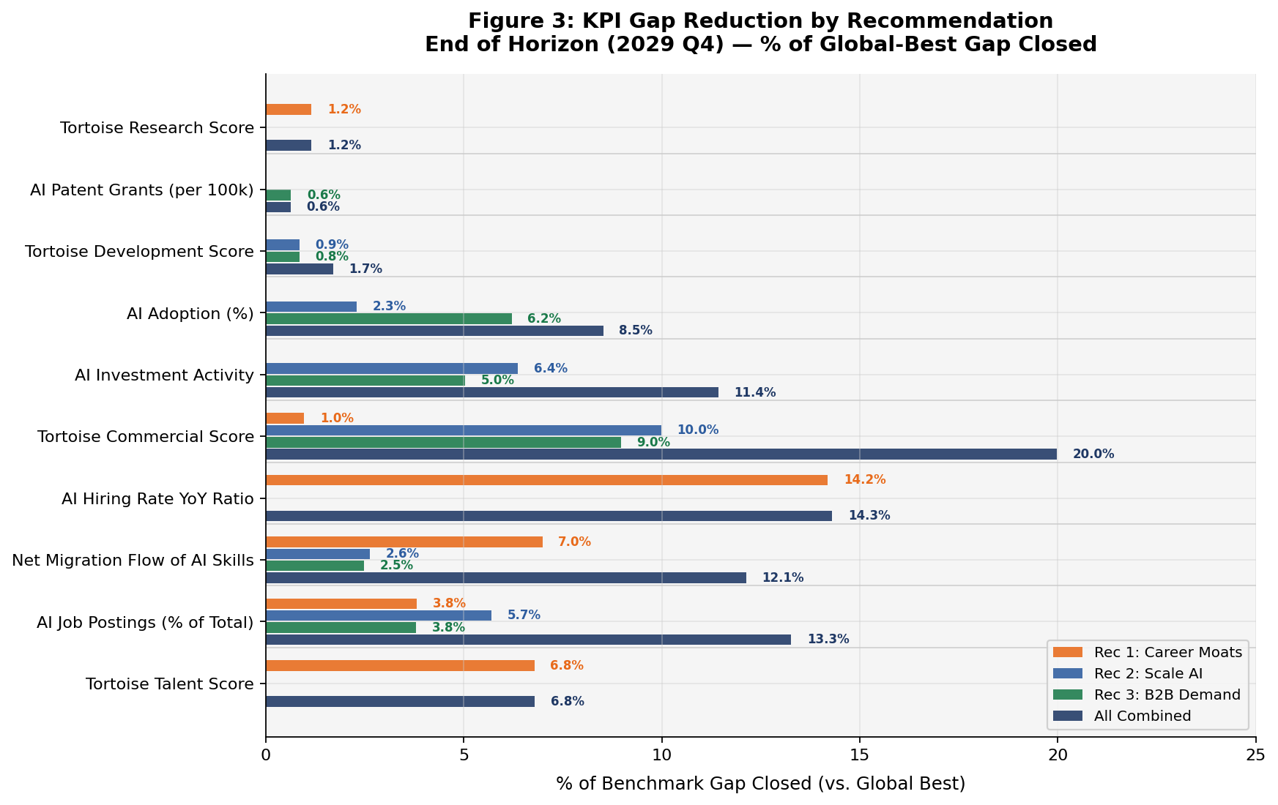
Figure 3: KPI Gap Reduction by Recommendation — % of Global-Best Gap Closed at End of Horizon (2029 Q4). Each recommendation shown stand-alone and combined.

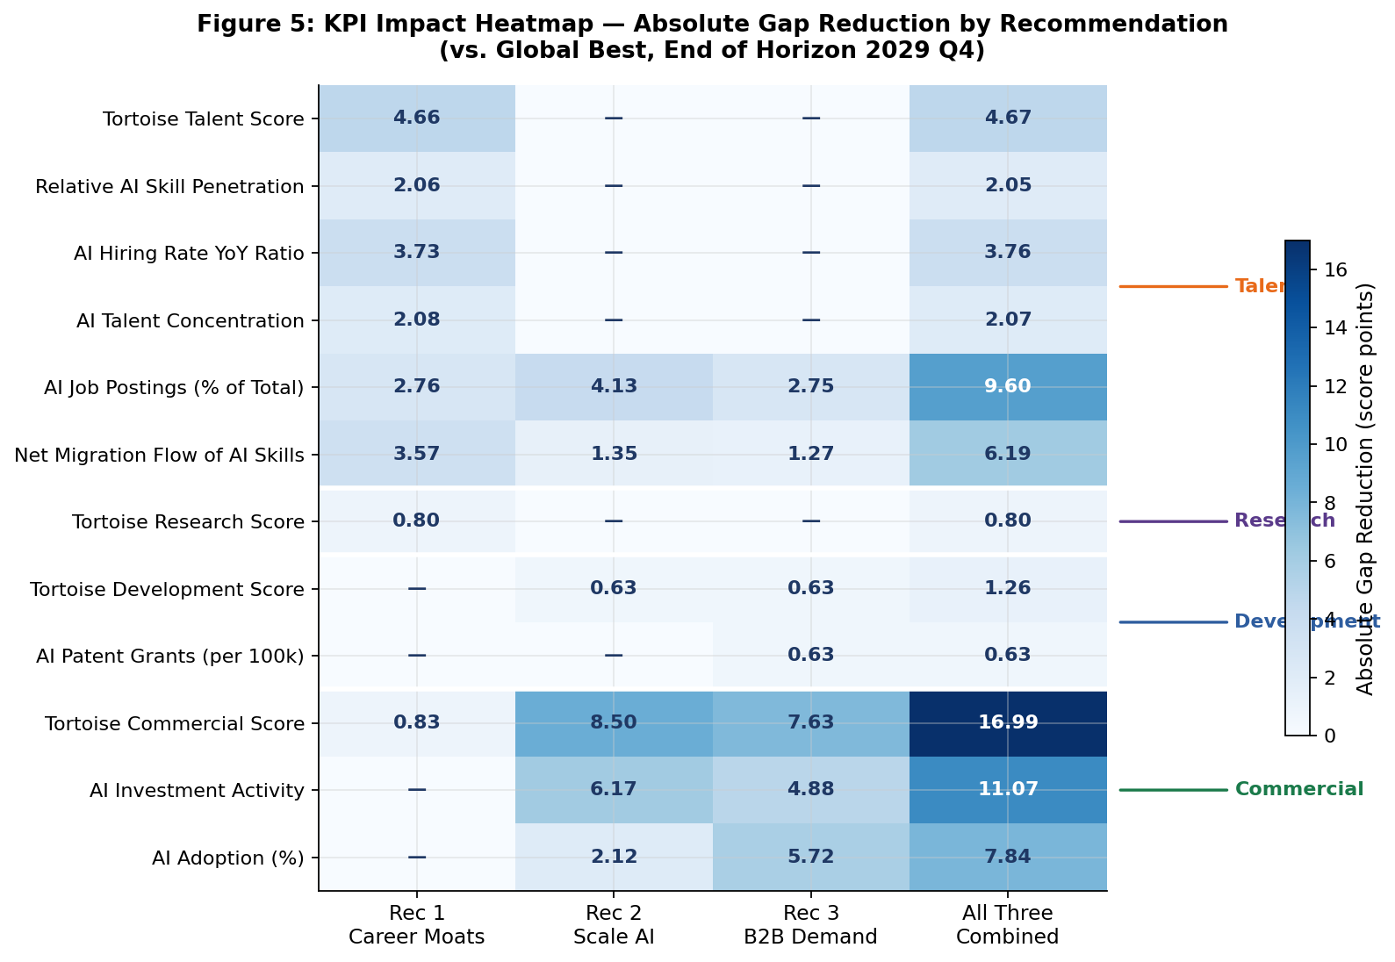
Figure 5: KPI Impact Heatmap — Absolute Gap Reduction by Recommendation (score points vs. global best, 2029 Q4). Darker shading = larger improvement.

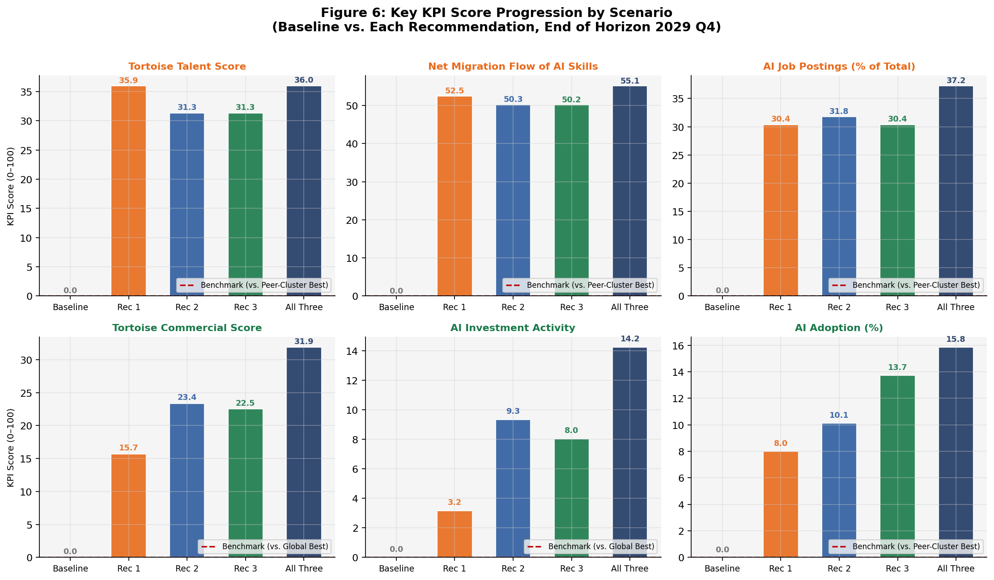
Figure 6: Key KPI Score Progression by Scenario — Baseline vs. Each Recommendation (2029 Q4). Red dashed line = benchmark target.

5.4 Operational Success and Early Indicators

Operational success under this strategy should be evaluated against leading indicators observable before composite rank movements become visible. The following signal categories are most useful for confirming that implementation is on track.

- Talent retention: Net migration flow of AI skills stabilizing or turning positive within four to six quarters of programme launch, as the equity tax exemption and fast-track visa stream begin processing applicants.
- Labour market demand signals: AI Job Postings as a share of total employment rising within two to three quarters of Recommendation 1 activation, as employer incentives attract earlier-stage AI hiring.
- Commercialization pipeline: Series B and later-stage funding rounds for Canadian-owned AI firms increasing within four to six quarters of Recommendation 2’s co-investment vehicles becoming operational, with federal procurement pilot-to-contract conversions providing a non-market validation signal.
- Adoption uptake: First-customer AI adoption tax credit claims rising within two to four quarters of Recommendation 3’s launch, with clawback enforcement monitored as a signal of programme integrity.
- Composite score movement: A meaningful increase in Canada’s composite score (approximately 1.0–1.5 points above baseline) should be observable by 2027 Q3–2027 Q4 if all three recommendations are progressing on schedule.

6. Strategic Interpretation of Results

The modelled results are best understood not as a forecast but as a structured assessment of what becomes possible if Canada acts, and what is likely to happen if it does not. The central projection represents a realistic, policy-informed trajectory under the median Monte Carlo outcome — not a guarantee, but a grounded basis for strategic decision-making.
The most important strategic insight is directional: Canada’s competitiveness gap is not primarily a resource or infrastructure gap. It is a conversion gap. Canada holds a maxed Government Strategy score and near-maxed Operating Environment score. Its research community produces internationally recognized work, and its academic-industry concentration is the strongest in the peer cluster. The problem is that this policy and research strength does not translate into retained talent, scaled commercial firms, or demonstrated domestic AI adoption at a rate commensurate with Canada’s 5th-place position.
The three recommendations are specifically calibrated to address that conversion failure, each targeting a different stage of the pipeline. Recommendation 1 addresses the exit problem: highly trained AI professionals are leaving or not arriving in sufficient numbers, because the financial and immigration incentives available in Canada remain less competitive than those in the United States and United Kingdom. The Career Moats package — equity tax exemptions, salary-matching credits, and a dedicated elite AI visa stream — does not attempt to match US scale. It aims to reduce friction at the margin, where individual retention decisions are made. The modelled talent KPI improvements reflect this logic: the biggest gains are in net migration flow, job postings, and hiring rates — indicators that respond to near-term incentive structures, not long-run infrastructure.
Recommendation 2 addresses the scale problem: even where talent stays, Canada lacks the commercial vehicles to convert research credibility into scaled firms. Compute subsidies, growth-stage co-investment, and federal procurement pilots directly target the three most common failure points in the commercialization pipeline — compute access, capital access, and access to a first institutional customer. The modelled improvements in Commercial Score, Investment Activity, and Development Score are the most direct expression of pipeline activation. Notably, Recommendation 2 produces the largest stand-alone composite gain after Recommendation 3, largely because the Commercial Ecosystem pillar carries significant weight in the model and investment activity compounds over time.
Recommendation 3 addresses the demand problem: without a credible domestic market for AI products, neither talent retention nor firm scaling reaches its potential. A 30–40% refundable first-customer adoption tax credit, paired with IP eligibility rules and pilot-to-contract conversion mandates, creates the demand signal that makes the other two recommendations viable in the medium term. The modelled adoption improvements are the most rapidly observable in the simulation, reflecting the near-term responsiveness of enterprise purchase decisions to financial incentives.
Together, the three recommendations form a reinforcing package rather than three independent policy actions. Talent moats without commercial scale vehicles produce retained talent that eventually exits again when growth-stage opportunity remains limited. Commercial scale vehicles without domestic demand produce firms that are serially undercapitalized or forced to seek US customers. And adoption credits without strong talent and a viable domestic firm ecosystem stimulate demand that gets met by foreign AI products rather than Canadian ones. The package is designed to close that loop: talent stays, firms scale, and domestic demand validates and accelerates the cycle.
The results are realistic in their modelled magnitude. The combined composite gain of approximately 4.07 points represents roughly a 12% improvement above Canada’s baseline score — meaningful, but not unprecedented for a coordinated policy package of this scope implemented over a three-to-four year window. The most comparable international precedents suggest that talent retention and early-stage commercialization programmes can produce KPI movements of this order when implementation is well-coordinated. The modelled results do not assume structural changes in Canada’s infrastructure or a fundamental shift in the global AI investment landscape. They assume only that the three recommended levers are implemented on the specified timeline and achieve effects calibrated against observed experience in comparable jurisdictions.

7. Conclusion

Canada occupies a paradoxical position in the global AI landscape. It has the policy architecture of a leading nation — a perfect Government Strategy score, a strong regulatory environment, and internationally respected research institutions — but the commercial and talent outcomes of a country still trying to convert that architecture into economic results. The central argument of this analysis is that the gap is not strategic ambition: it is execution in three specific, addressable areas.
The three recommended actions — Career Moats for Talent Retention, Conditions to Scale AI Firms, and B2B Demand Stimulus via Adoption Credits — were selected because they address the most consequential conversion failures in the Canadian AI ecosystem, are bounded within federal authority and budget capacity, and are calibrated against demonstrated international experience. They are not the only interventions Canada could pursue, but they are the ones most likely to produce observable competitiveness gains within the three-to-four year window where decisions made today will have visible effects.
The modelled results support this prioritization. Implemented together, the package is projected to raise Canada’s composite AI competitiveness score from 32.86 to approximately 36.93 by end of 2029 — a gain of roughly 4.07 points, or a 12% improvement above baseline. Canada’s rank is projected to move from a deteriorating 6th under the no-action baseline to a stable 4th by the end of 2027, maintained through the end of the horizon. The three recommendations produce complementary effects across talent, commercialization, and demand KPIs, with the commercial ecosystem showing the largest absolute improvement and the talent cluster showing the most important structural stabilization.
The critical message for decision-makers is this: Canada does not need to outspend the United States or outscale China to materially improve its competitive position. It needs to close specific, bounded gaps in talent conversion, commercial scale-up capacity, and domestic market demand — gaps that are measurable, trackable, and addressable with policy instruments already within federal reach. The recommended package is designed precisely for that purpose.
If implemented with fidelity and monitored against the leading KPI indicators identified in this analysis, Canada is well-positioned to consolidate and extend its standing as one of the top four AI economies in the world. Inaction carries a different and less favourable trajectory. The window to act is open.

8. Limitations and Interpretation Caution

The projected results in this report are scenario-based estimates, not point forecasts. Several interpretation cautions apply and should be carried through to any executive presentation of these findings.
First, the stand-alone scenario results for each recommendation are counterfactual estimates against a frozen baseline. They are designed to illustrate the directional effect of each policy bundle in isolation. These stand-alone impacts are not strictly additive: the three recommendations share overlapping KPI targets, interact over time, and may move some of the same outcomes through different channels. The combined scenario is modelled as an integrated package, not as the arithmetic sum of three stand-alone runs, and should be treated as the primary projection for strategic planning purposes.
Second, the central projection reflects the median Monte Carlo outcome. The underlying model explicitly quantifies uncertainty as an interquartile range, visible in the trajectory charts. The median provides a credible central estimate for decision-making, but outcomes at the upper and lower bounds of the modelled range remain possible depending on implementation quality, external conditions, and competitive responses from peer nations.
Third, the model benchmarks Canada against its natural peer cluster — the United Kingdom, Germany, France, and Spain — as the headline comparator. Global-best benchmarks are used where the peer cluster is itself structurally weak, such as in development output and patent conversion. Using global best as the headline benchmark for all KPIs would overstate Canada’s gap and produce implausible near-term improvement targets.
Finally, the model does not account for exogenous shocks, major regulatory changes, or structural shifts in the global AI investment environment. These are reasonable assumptions for scenario planning, but they reinforce the importance of ongoing monitoring and adaptive management as implementation proceeds.

Key Interpretation Note
Each recommendation is presented as a separate stand-alone counterfactual against the same Canada baseline. Effects are not additive. The recommendations overlap on several KPIs, interact over time, and may move some of the same outcomes through different channels. The combined scenario is the primary strategic projection; stand-alone results illustrate attribution, not a summable total.

End of Section | MIE1624 Canada AI Competitiveness Project | University of Toronto, Winter 2026

